CS 300 HW4

Emir Asal 27933

Question 1

Not labeled nodes have infinity distance.

Initially,
Unvisited Nodes = {E, F, C, A, B, H, G, D}
We visit E

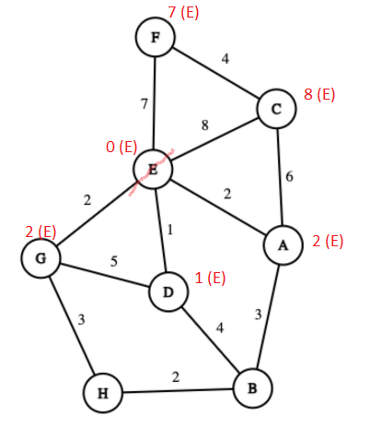

We visit D
Unvisited Nodes = {F, C, A, B, H, G}
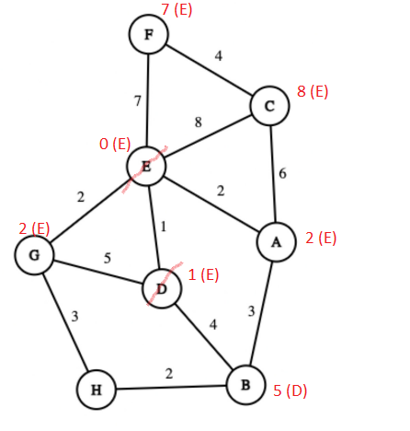

Unvisited Nodes = {F, C, A, B, H, G}
We visit G
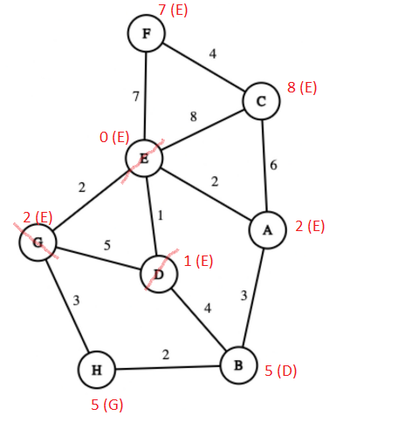

Unvisited Nodes = {F, C, A, B, H}
We visit A
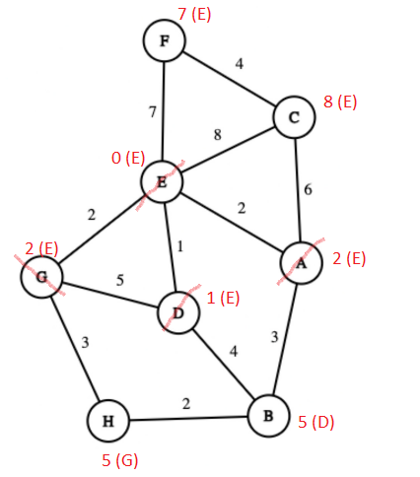

Unvisited Nodes = {F, C, B, H}
We visit H

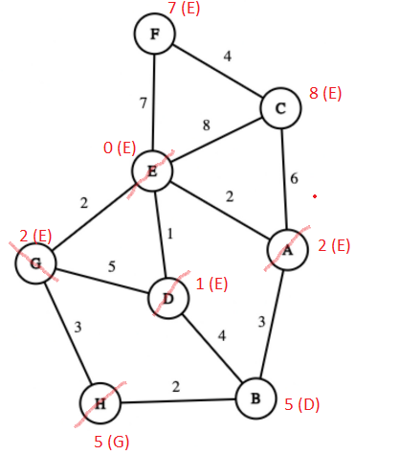

Unvisited Nodes = {F, C, B}
We visit B
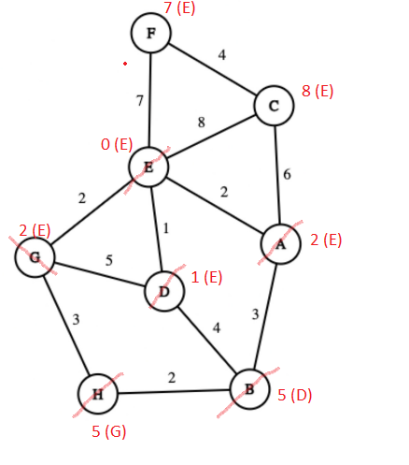

Unvisited Nodes = {F, C}
We visit F
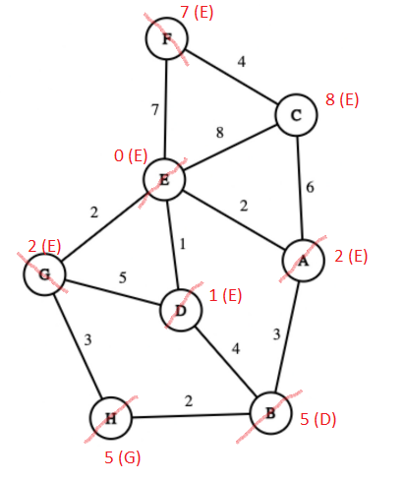

Unvisited Nodes = {C}
We visit C
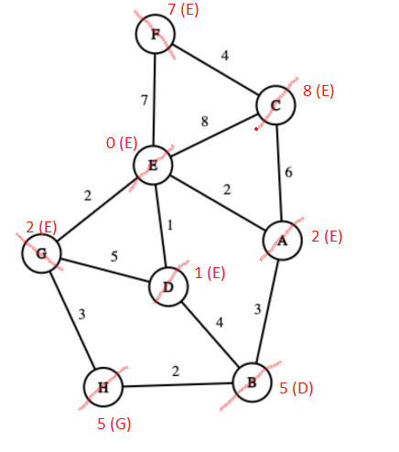

Final Result:
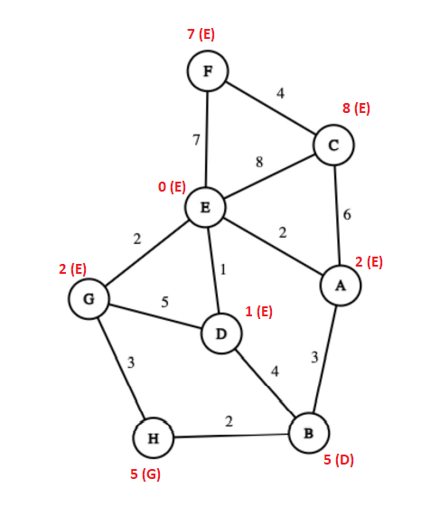

Question 2

First we choose the minimum edge from E.
Visited Nodes = {E, D}
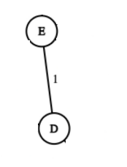
Smallest edge from these nodes is E-G
Visited Nodes = {E, D, G}
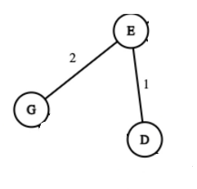
Smallest edge from these nodes is E - A
Visited Nodes = {E, D, G, A}
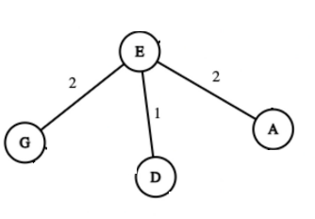

Smallest edge from these nodes is G-H
Visited Nodes = {E, D, G, A, H}
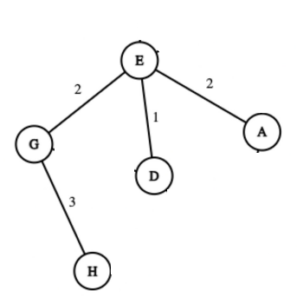

Smallest edge from these nodes is H - B
Visited Nodes = {E, D, G, A, H, B}
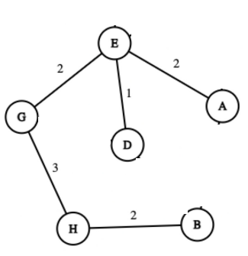

Smallest edge from these nodes is C-A
Visited Nodes = {E, D, G, A, H, B, C}
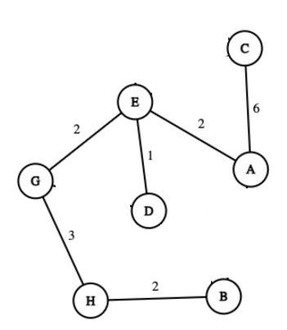

Smallest edge from these nodes is C-F
Visited Nodes = {E, D, G, A, H, B, C, F}
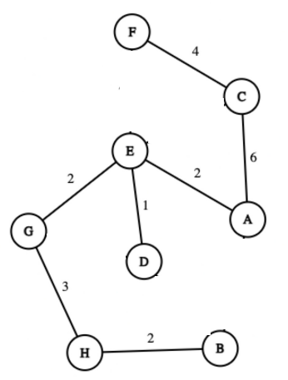

Every node is visited, final distances:
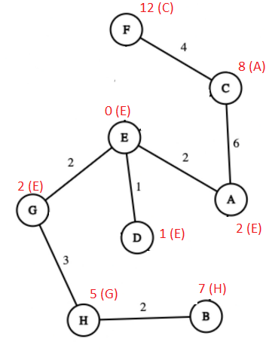

Question 3

First, we select the minimum edge E-D (1)
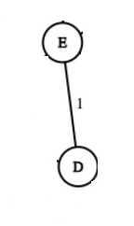

and then E-G (2)
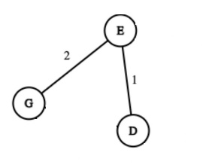

and then E-A (2)
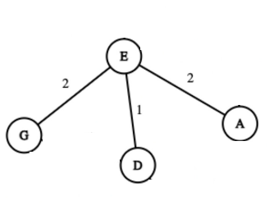
and then H-B (2)
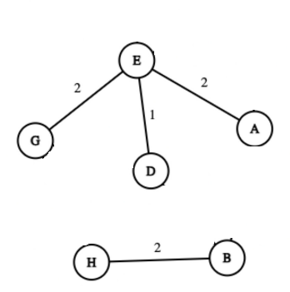
and then G-H (3)
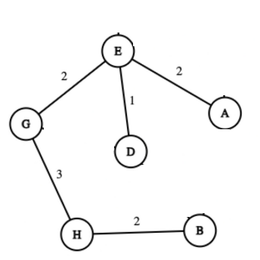
and then F-C (4)
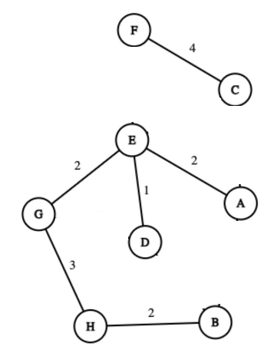

and then A-C (6) so the Final result is:
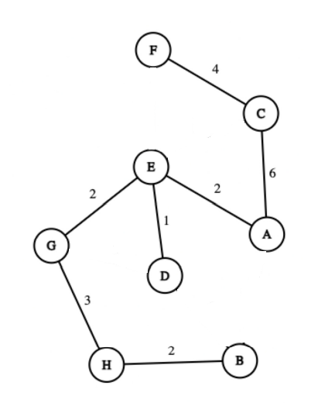

Question 4

Starting from E, we consider 1 edges away:
E - A - C - F - G - D
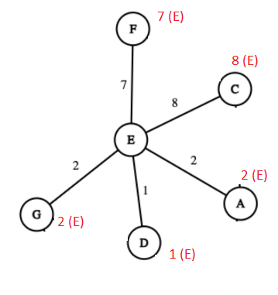

And then two edges away from the starting node and after that every node is visited :
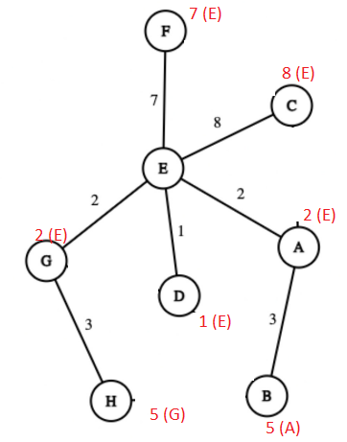

Question 5
We are counting the number of “in degrees” and order them by removing the node that has the lowest “in degree”.

Initially:

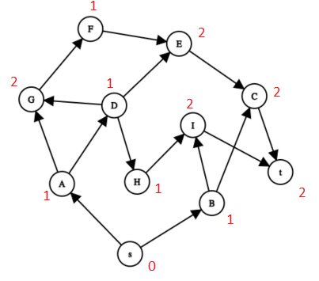
Removing s

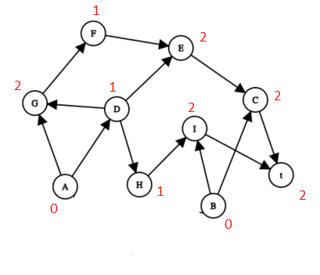
Order: s →

Removing B
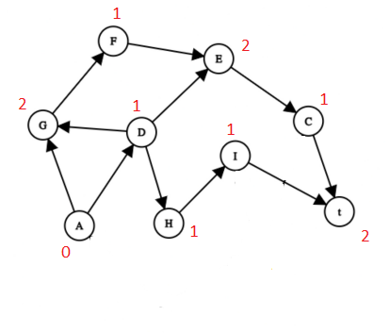
Order: s → B

Removing A
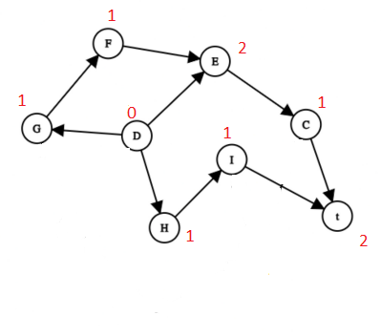
Order: s → B → A

Removing D
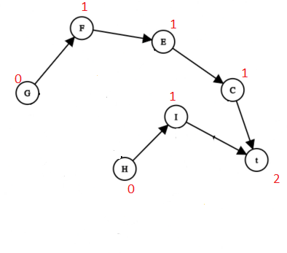
Order: s → B → A → D

Removing G

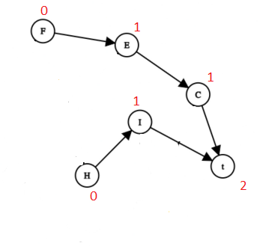
Order: s → B → A → D → G

Removing H
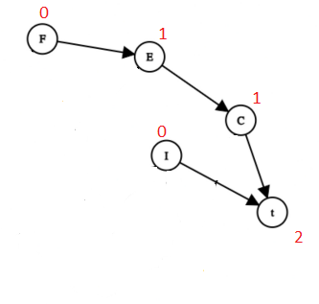
Order: s → B → A → D → G → H

Removing F
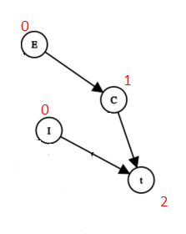
Order: s → B → A → D → G → H → F

Removing I

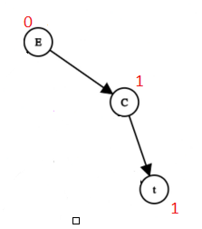
Order: s → B → A → D → G → H → F → I

Removing E

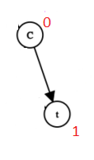
Order: s → B → A → D → G → H → F → I → E

Removing C
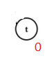
Order: s → B → A → D → G → H → F → I → E → C

Removing the last element t
Order: s → B → A → D → G → H → F → I → E → C → t

Final result:
s - B - A - D- G - H - F - I - E - C - t

